COGNIFYZ TECHNOLOGIES
Data Science Internship
TASK 3: Geospatial Analysis
Intern: Pranav KS
Role: Data Science Intern
Level: Level 1

Objective
To visualize the geographical distribution of restaurants and investigate whether restaurant location is associated with restaurant ratings.

Data Preparation
The dataset was loaded using Pandas. The Latitude, Longitude, City, Country Code, and Aggregate rating columns were used for geographical and rating analysis. Missing latitude and longitude values were excluded from the map visualization.

Restaurant Locations on Map
An interactive map was created using Folium. Latitude and longitude values were used to plot restaurant locations. Each restaurant is represented by a circular marker, and clicking a marker displays the city and aggregate rating.

City-wise Distribution
The number of restaurants in each city was calculated using value_counts(). The cities with the highest number of restaurants were identified and visualized using a bar chart.
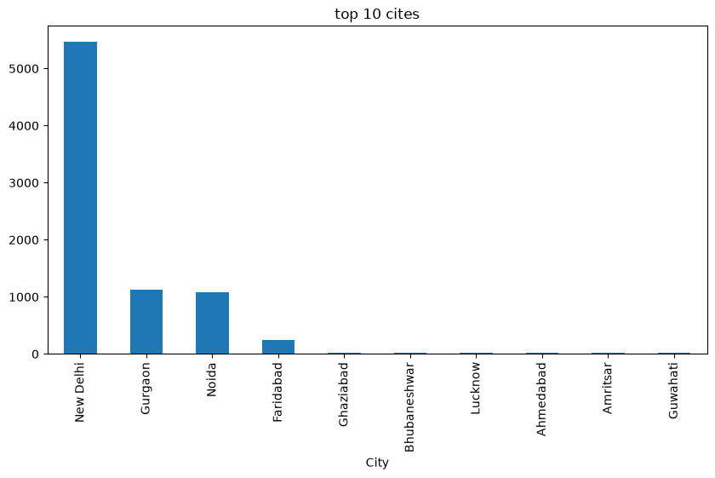

Country-wise Distribution
The number of restaurants in each country was calculated using the Country Code column. This analysis shows how restaurants are distributed across different countries.
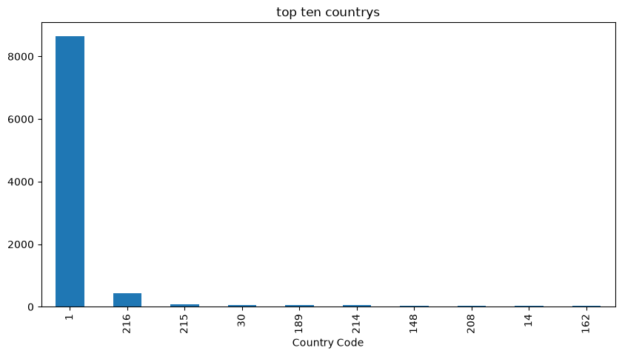

Location and Rating Analysis

The average aggregate rating was calculated for different cities. Latitude and longitude can also be compared statistically with aggregate rating. This analysis describes association only and does not establish that location causes a particular rating.
restaurant_count average_rating
City
New Delhi 5473 2.438845
Gurgaon 1118 2.651431
Noida 1080 2.036204
Faridabad 251 1.866932
Ghaziabad 25 2.852000
Bhubaneshwar 21 3.980952
Lucknow 21 4.195238
Guwahati 21 4.190476
Ahmedabad 21 4.161905
Amritsar 21 3.685714

Key Observations
• The interactive map shows the geographical concentration of restaurants.
• Some cities contain substantially more restaurants than others.
• Restaurant counts vary across countries.
• Average ratings can differ between cities.
• A geographical correlation with rating should be interpreted carefully because other factors may affect restaurant ratings.

Conclusion
The analysis provides a geographical overview of the restaurant dataset. Interactive mapping, city/country distribution, and city-level rating analysis help identify patterns in restaurant locations and ratings.

